# Roles:

App Development: Noah, Thomas

Diagram/Flowchart: Cecilia*

Storyboard: Thomas*

Rules: Tvisha*

Modeling: Toni

Board: Will

Board Aesthetics: Tvisha

Tutorial Graphics: Tvisha

Stars would work together but Cecilia will head with the flowchart

# November 28, 2022:

### Goal:

Beat mutated crab boss

8 keys to boss

### Round:

Each player does 1 turn

Mini-boss chance to spread/spawn

### Turns:

Change space

Change room

Fight mini-boss

### Mini-Boss Turns:

Mini-boss spawns at end of the round

Fight at beginning of the next round

### Board Divisions:

Spawn: Common Room

Cafeteria

Dock

Exterior

Botany

Dorms

Research

Administration

Files

Boss: Redacted (Stranger Things where they kept the demi-Gorgan style)

### Rooms:

Has 4 doors

3 spaces

### Spaces:

Task

* 4 decrypt questions
* 2 Matching DNA questions
* 1 crab v human question
* 1 selfish-ism question

Firewall

* Simon says with colors

Chance

* Extra move
* No move
* Spawn mini-boss
* Kill/prevent mini-boss
* Nothing

### Mini-Boss:

Represented by tokens

Each round

* Percent chance to spawn at end of the round

Mini-bosses lockdown room

Crab trivia

Trivia

* 2 attempts
* 1 question
  + Per mini-boss

The crab goes poof and the player loses a turn on failure

### Final Boss:

After 8 keys teleport to the room

HP-Based

* 1 decryption question +++
* 1 matching question ++
* 1 moral question ++
* 4 trivia +

Health = 8?

Could win and lose

End game after the boss is defeated or there are no more questions

Credits and conclusion

### Models:

4 players

4 customs for players

1 boss

8 tokens

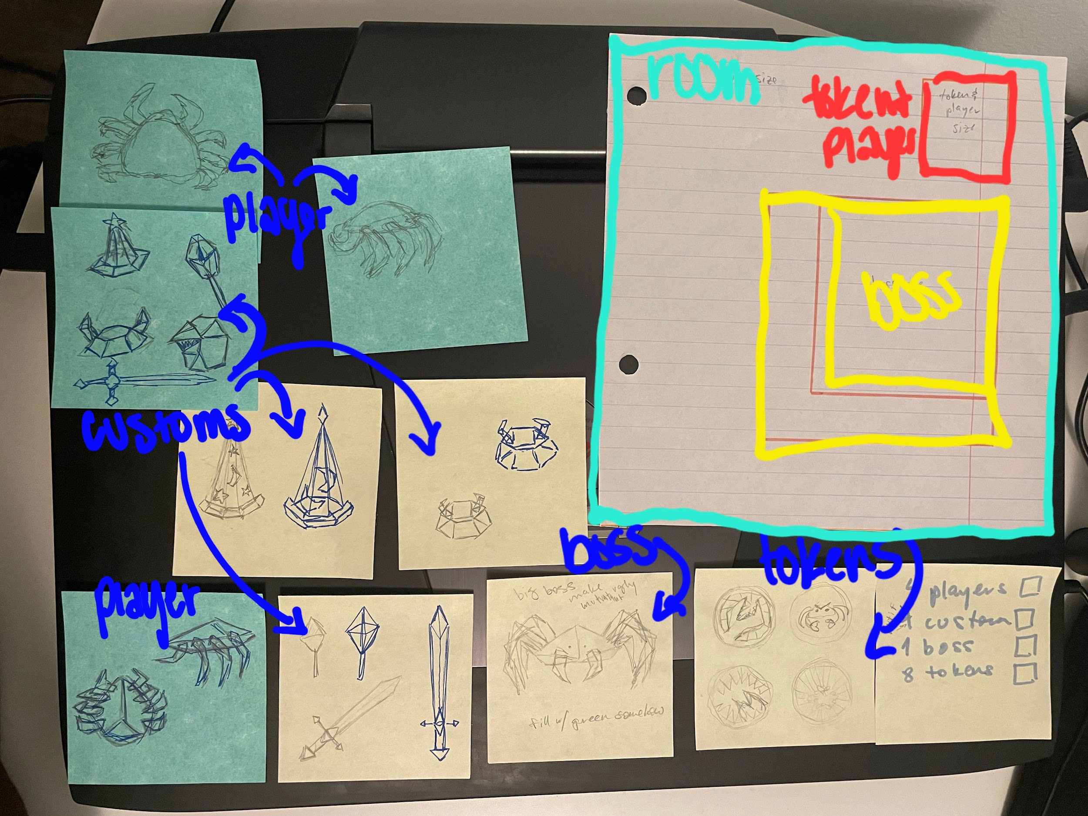

### Board:

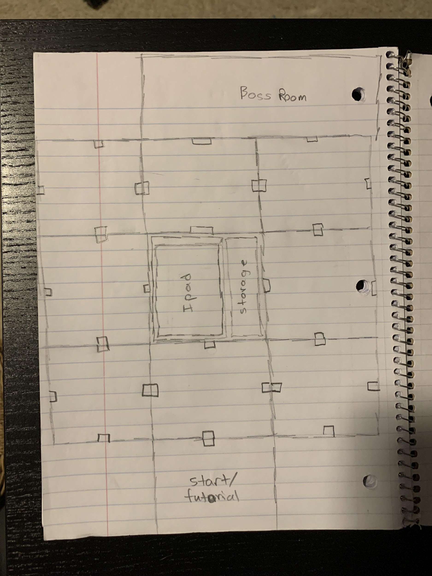

Spaces are 4 cm x 4 cm

Board pieces are 24 cm x 24 cm

8 main pieces are modular

The start/tutorial and the boss room can be placed wherever

The center box will hold an iPad and storage for models

### Board Design:

Peg system to hold board quadrants together and create a peg holder system

2’ x 2’

Design action tiles/spaces into board design

Run-down lab

**The Crab Lab**

Storage in center

Stand for iPad

iPad on side

Lazy Suzzane the stand

### Intro:

* Describe boss
* Describe situation
* Tvisha designs simple drawings for backgrounds

### Conclusion:

Win: re-edit boss genes, woo

Lose: boss overtakes the entire population

### Tutorial Question:

Task description question: 000101 give the binary tree

### Task Questions:

2 with binary -> how to read binary

2 with hex -> how to read hex

Matching DNA questions -> Noah does

Crab v. human question: what life is valued more aka crab

Is it ok to sell user information without their consent

### Boss Questions:

Harder binary tree

Matching -> Noah does this

Better to read terms or trust

### Trivia Questions (12):

1. Legs
2. Eggs
3. Longest lifespan (Boss)
4. Group called (Boss)
5. How many species (Boss)
6. Smallest crabs
7. False crabs (Boss)
8. Diet
9. Exoskeleton
10. Most colorful
11. Habitat
12. Regenerate

### Research Resources:

GMO on Youtube

Kergesagt

### To Do:

Make a rule for Sunday

Make questions for Sunday

Send finalized room designs to Noah

2 digital graphics (png)

* Boss
* Situation

### Progress Report To Do List:

App To Do:

* ~~Make tutorial N~~
* ~~Make Simon Says N~~
* ~~Make boss N~~
* ~~Make mini boss N~~
* Documentation N
* ~~Conclusion pngs Tv~~
  + ~~Win~~
  + ~~Loose~~
* ~~Finalize sentences C~~
  + ~~Intro~~
  + ~~Conclusion~~
* ~~Credits C~~
* ~~Binary how to C~~
* ~~Alphanumeric key C~~
* ~~Matching DNA questions N~~
* ~~Binary questions N~~
* ~~Alphanumeric question N~~

| Binary | | Matching | | Text | | Alphanumeric | Trivia | |
| --- | --- | --- | --- | --- | --- | --- | --- | --- |
| 1 | 4 | 2 | 1 | 2 | 1 | 1 | 8 | 4 |
| Tutorial | Room | Room | Boss | Room | Boss | Boss | Mini boss | Boss |
|  |  |  | 2 points |  | 2 points | 3 points |  | 1 point |

Board To Do:

* ~~Cut wood base W~~
* ~~Instal dowel system W~~
* ~~Boss room W~~
* ~~Botany room W~~
* ~~Research room W~~
* ~~Admin room W~~
* ~~Cafeteria room W~~
* ~~Files room W~~
* ~~Print poster board W~~
* ~~Cut poster board W~~
* ~~Customizations To~~
* Print models C
* ~~Add stabilizers Y~~
* ~~Add models to drive C~~

General To Do:

* ~~Rules C~~
* Flowchart C
* Code Link N
* Video E
* ~~Questions Database C~~

### Game Name

Crab Lab

### Room Designs:

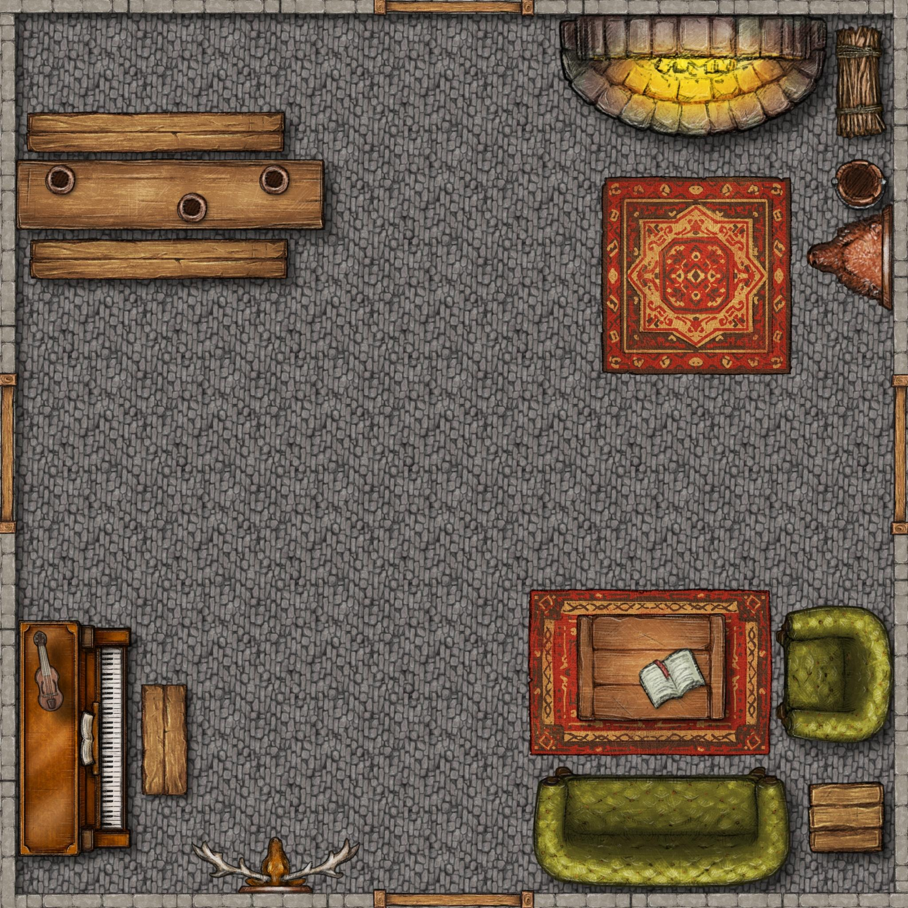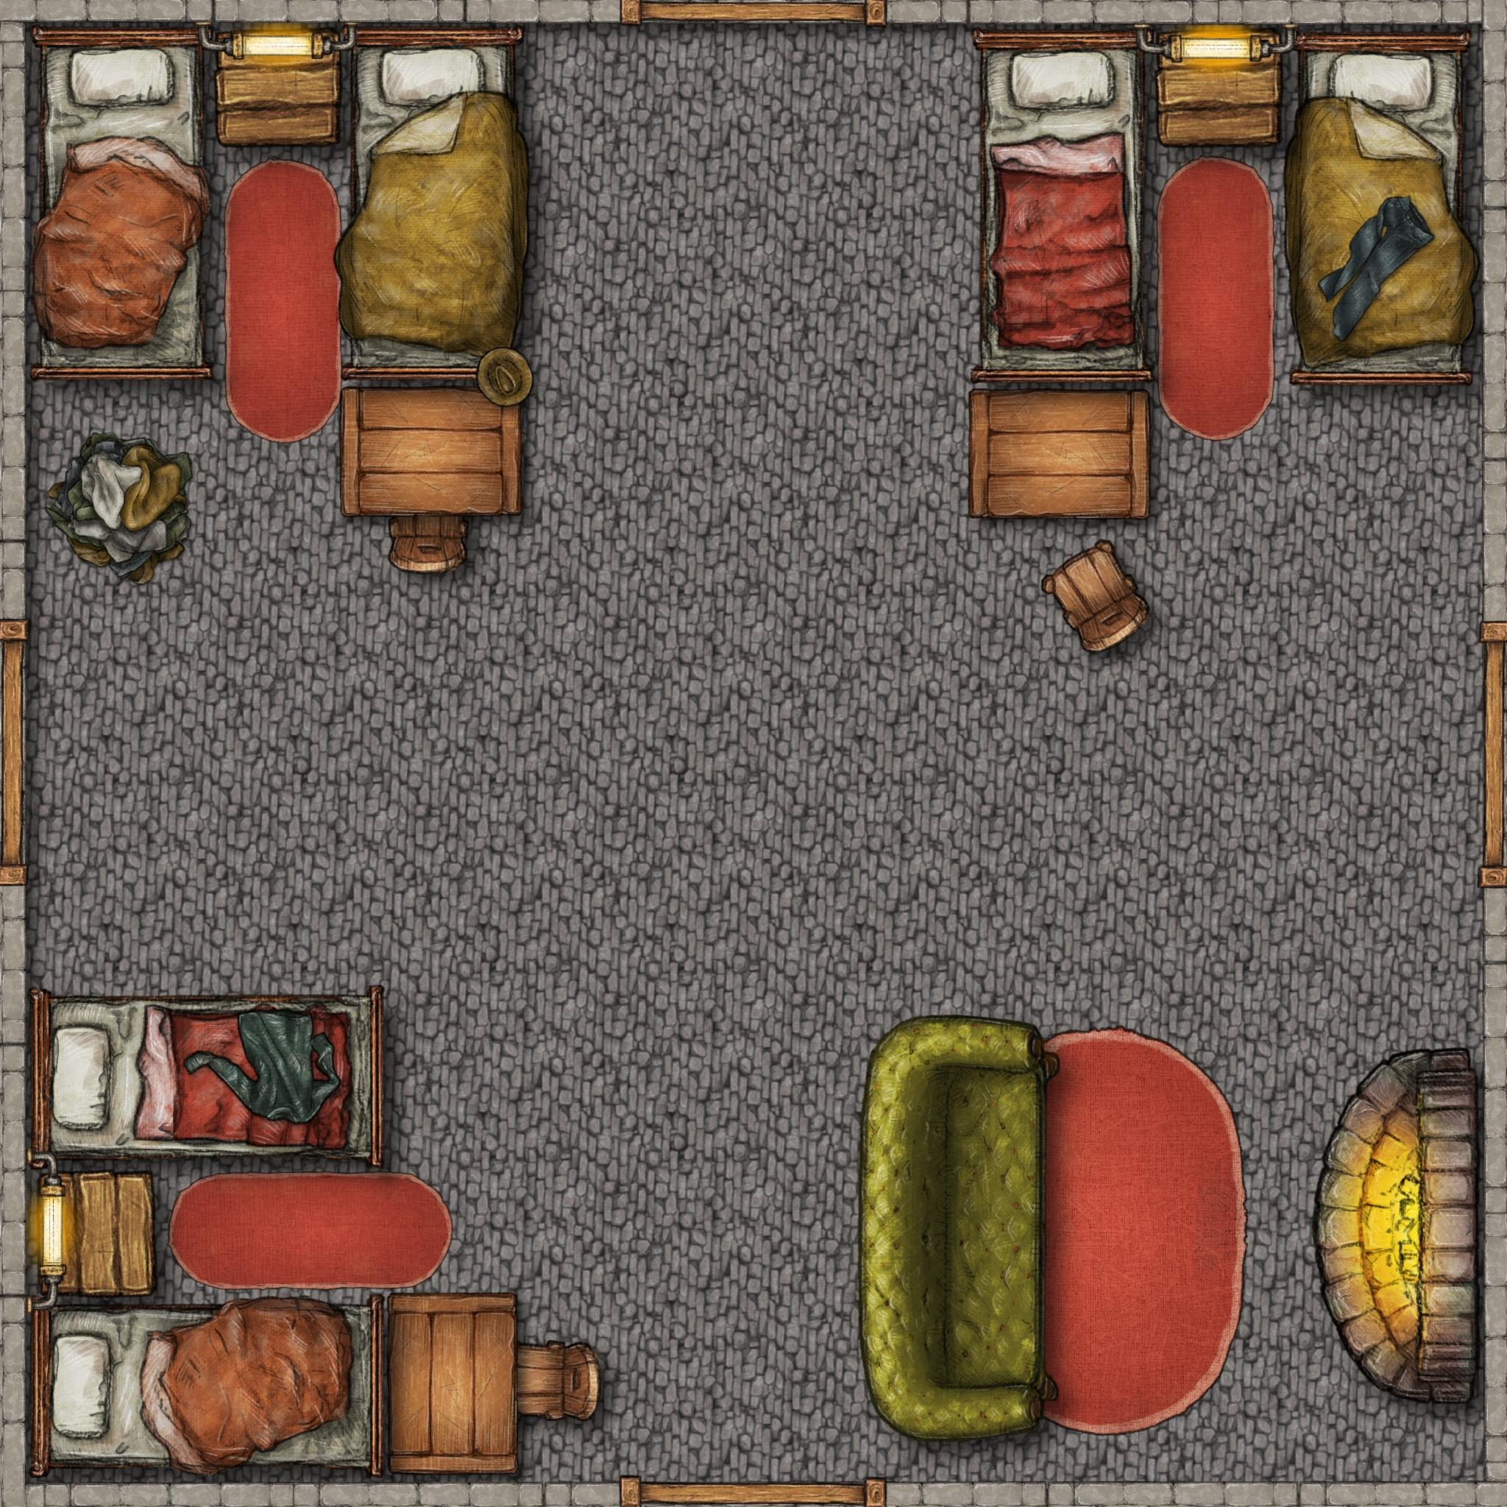

### Questions:

